Key Event Information – The New England Venture Summit
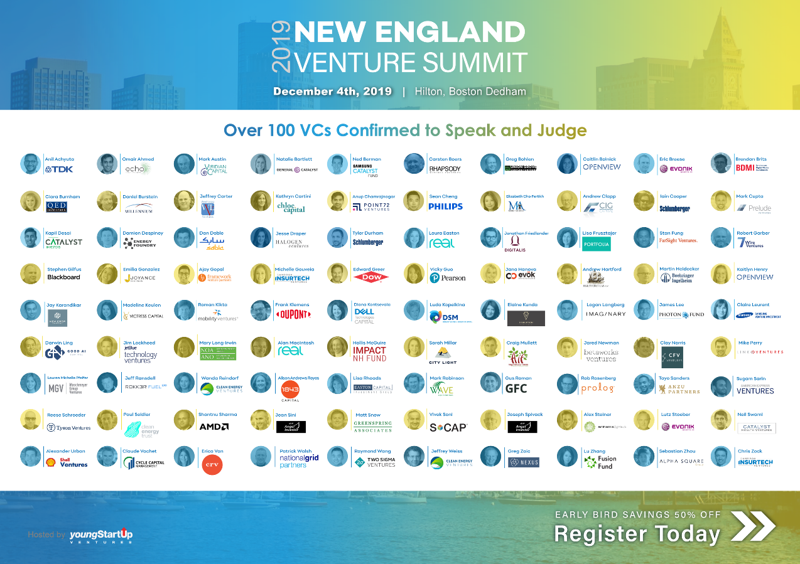

Meet, interact and network with more than 800 VCs, Corporate VCs, angel investors, investment bankers and founders of venture backed, emerging and early stage companies at the prestigious New England Venture Summit being held on December 4th 2019 at The Hilton, Dedham, MA.

Whether you’re a startup seeking capital and exposure, or an investor seeking new deals, The New England Venture Summit presented by youngStartup Ventures - is the event of the year you won't want to miss.

A highly productive venture conference, The New England Venture Summit is dedicated to showcasing leading VCs, Corporate VCs and angel investors committed to funding venture backed, emerging and early stage companies. Featuring a dedicated Tech Track.

Partial List of Over 100 VCs & Angel Investors confirmed to speak and judge includes:
Anil Achyuta, Investment Director, TDK Ventures | Omair Ahmed, Associate, Echo Health Ventures | Mark Austin, Managing Director, Viridian Capital | Natalie Bartlett, Investor, General Catalyst | Ned Berman, Senior Associate, Samsung Catalyst Fund | Carsten Boers, Managing Partner, Rhapsody Venture Partners | Greg Bohlen, Managing Director, Union Grove Venture Partners | Caitlin Bolnick, Investor, OpenView Venture Partners | Maureen Boyce, Managing Partner, Good Growth Capital | Eric Breese, Investment Manager, Evonik Venture Capital | Brendan Brits, Investor, Bertelsmann Digital Media Investments | Ciara Burnham, Partner, QED Investors | Daniel Burstein, Managing Partner, Millennium Technology Value Partners | Jeffrey Carter, General Partner, West Loop Ventures | Kathryn Cartini, Partner, Chloe Capital | Anup Chamrajnagar, Investor, Point72 Ventures | Sean Cheng, Investment Manager, Philips Ventures | Elizabeth Cho-Fertikh, Co-Founder & Managing Director, MEDA Angels | Tyler Churchill, Vice President, Bonfire Ventures | Andrew Clapp, Managing Director, CIG CAP | Iain Cooper, Manager Corporate Ventures, Schlumberger Technology Investments | Mark Cupta, Partner, Prelude Ventures | Kapil Desai, Vice President, Catalyst Investors | Damien Despinoy, Director, Energy Foundry | Dan Doble, Managing Director, SABIC Ventures | Jesse Draper, Founding Partner, Halogen Ventures | Tyler Durham, Principal, Schlumberger Technology Investments | Laura Easton, Analyst, Real Ventures | Jonathan Friedlander, Principal, Digitalis Ventures | Lisa Frusztajer, Lead Investor, Portfolia Enterprise Fund | Ernestine Fu, Venture Partner, Alsop Louie Partners | Stan Fung, Managing Director, FarSight Ventures | Robert Garber, Partner, 7wire Ventures | Stephen Gilfus, Founder, Blackboard Inc. | Elianna Goldstein, Analyst, Boeing HorizonX Ventures | Emilia Gonzalez, Principal, Joyance Ventures | Ajay Gopal, Founding Principal, Framework Venture Partners | Michelle Gouveia, Associate, Sandbox Insurtech Ventures | Edward Greer, Corporate Technology Scout, Dow Ventures | Vicky Guo, Investment Director, Pearson Ventures | Brooke Hammer, Associate, F-Prime Capital Partners | Jana Hanova, Director, Evok Innovations | Andrew Hartford, Managing Partner, Hartford Lab | Martin Heidecker, Director, Investment Manager, Boehringer Ingelheim Venture Fund | Kaitlyn Henry, Associate, OpenView Venture Partners | Toan Huynh, Partner, Information Venture Partners | Del Johnson, Principal, Backstage Capital | Jay Karandikar, Venture Partner, New Crop Capital | Madeline Keulen, Vice President, Victress Capital | Roman Kikta, Managing Partner & Founder, Mobility Ventures | Frank Klemens, Managing Director, DuPont Ventures | Diana Kontsevaia, Investor, Dell Technologies Capital | Ventures | Luda Kopeikina, Investment Director, DSM Venturing | Elaine Kunda, Founder & Managing Director, Disruption Ventures | Logan Langberg, Principal, Imaginary Ventures | Tiffany Le, Investor, Kaiser Permanente Ventures | James Lee, Investment Associate Director, Photon Fund | Claire Leurent, Managing Director, Samsung Ventures | Debbie Lin, Executive Director & Investment Manager, Boehringer Ingelheim Venture Fund | Darwin Ling, Founding General Partner, Good AI Capital | Jim Lockheed, Investment Associate, JetBlue Technology Ventures | Mary Long-Irwin, Executive Director, Northern Ontario Angels | Alan MacIntosh, General Partner, Real Ventures | Wasim Malik, Managing Partner, Iaso Ventures | Hollis McGuire, Director, Impact NH Fund | Philip Mertens, Investment Analyst, DSM Venturing | Sarah Millar, Associate, City Light Capital | Mark Miller, Managing Partner, Good Harbor Partners | Craig Mullett, Director, Angel Investor Forum | Jared Newman, Associate, Betawork Ventures | Clay Norris, Investment Associate, Carolinas Fintech Ventures | Mike Perry, Investment Associate, Link Ventures | Lauren Michelle Pfeifer, Principal, Maschmeyer Group Ventures | Jeff Ransdell, General Partner, Rokk3r Fuel ExO | Wanda Reindorf, Managing Director, Clean Energy Venture Group | Alison Andrews Reyes, General Partner, 1843 Capital | Lisa Rhoads, Managing Director, Easton Capital Investment Group | Mark Robinson, Founder and Managing Director, WAVE Equity Partners | Gus Roman, Venture Capital Associate, Global Founders Capital | Rob Rosenberg, Partner, Prolog Ventures | Brita Rosenheim, Partner, Better Food Ventures | Tayo Sanders, Associate, Anzu Partners | Sugam Sarin, Investment Manager, American Express Ventures | Jennifer Schretter, Partner, PROOF VC | Reese Schroeder, Managing Director, Tyson Ventures | Paul Seidler, Managing Director, Clean Energy Trust | Shantnu Sharma, Managing Director, AMD Ventures | Jean Sini, Angel Investor | Matt Snow, Analyst, Greenspring Associates | Vivek Soni, Venture Partner, S Cap Cleantech Fund | Joseph Spivack, Angel Investor | Alex Steiner, Investment Analyst, Anthemis Group | Lutz Stoeber, Investment Director, Evonik Venture Capital | Neil Swami, Principal, Catalyst Health Ventures | Byron Thom, Principal, Framework Venture Partners | Michael Thomas, Inova Health System Strategic Investments, Investment Director | Alexander Urban, Associate, Shell Ventures | Claude Vachet, Managing Partner, Cycle Capital Management | Erica Van, Investor, Charles River Ventures | Patrick Walsh, Director, National Grid Partners | Raymond Wang, Investor, Two Sigma Ventures | Jeffrey Weiss, Senior Venture Partner, Clean Energy Ventures | Henry White, Venture Partner, Good Growth Capital | Greg Zaic, Principal and General Partner, NMT Capital | Lu Zhang, Founder & Managing Partner, Fusion Fund | Sebastian Zhou, Investor, Alpha Square Group | Chris Zock, Managing Director, Sandbox Insurtech Ventures and many more...

Special Offer:
IEEE has made special arrangement for our network to receive a special discount of 10% off the existing “early bird" rates (which are 50% reduced). Early bird rates expire October 31st.

To Register now and receive the special discount as well as take advantage of the "Early bird" discount rate, use the link below and enter discount code "IEEEVIP” click here http://bit.ly/2Kxec23 Early bird rates expire October 31st.
.

Call for TOP INNOVATORS!
Get Noticed > Get Funded > Grow Faster

A select group of more than 100 Top Innovators from the Technology, Life Sciences/Healthcare, CleanTech and Fintech sectors will be chosen to present their breakthrough investment opportunities to an exclusive audience of Venture Capitalists, Corporate Investors, Private Investors, Investment Bankers, and Strategic Partners.

Apply to Present / Nominate a company:
For more information or to be considered for one of the Top Innovator slots click here.

Seed Pitchfest:
If you are a seed stage company seeking angel funding of less than $1M (and have raised less than $300,000) click here to apply for our Seed stage track.

